**CONNECT EMOTIV INSIGHT TO PC**

1. Assemble headset.
2. Plug in USB receiver.
3. Open Emotiv Xavier Control Panel (EXCP).

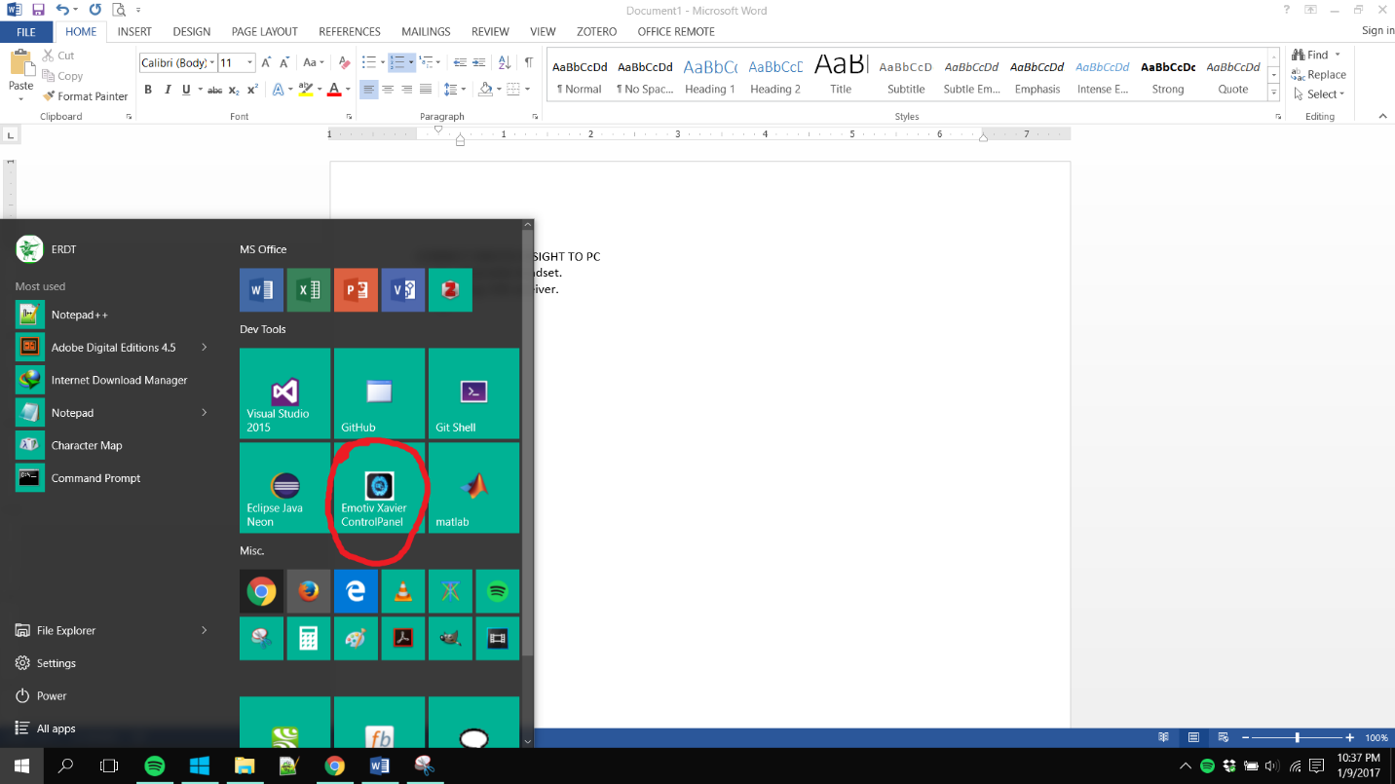

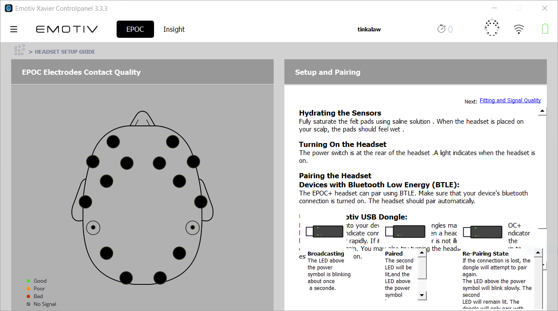

1. Plug USB receiver.
2. Turn on the headset by pressing the only button on the device. You should see the light indicator on the device (upper left on the EMOTIV logo) light up. The USB receiver should have two solid green lights. The EXCP should look like the image below.

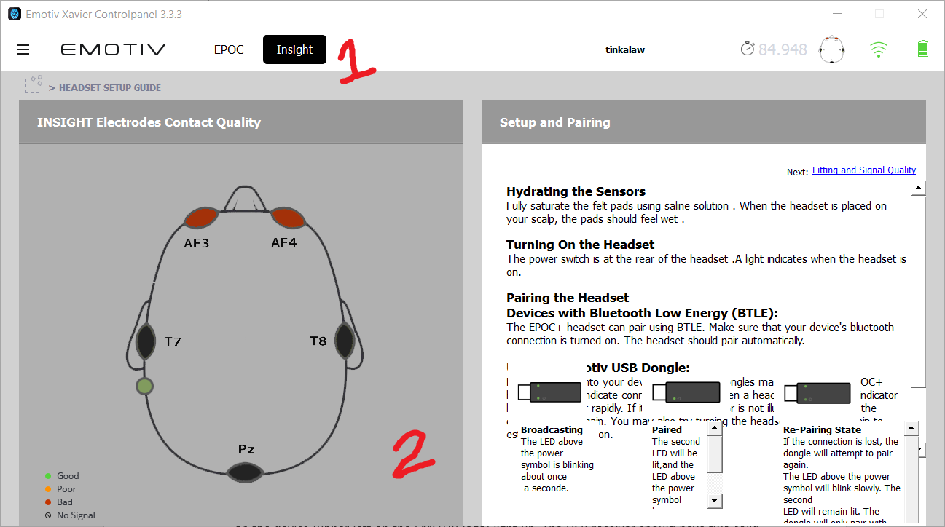

**BRIEFING**

1. Have the participant read the Informed Consent Form (ICF).
2. Explain the UI of the tool and the emotions he/she will tag (see Appendix A).
3. Ask if there are any questions, in need of a bathroom break, etc. If there are no more questions, have them sign the last page of the ICF.

**DATA COLLECTION PROPER**

1. Have the participant wear the Emotiv Insight headset. Attempt to have all sensors have a green signal.
2. Open the DataCollector.exe and input participant’s first name.
3. Get the baseline by clicking ‘Baseline’. You have a timer indicator on the tool. It won’t make a sound so just be ready for it to stop (lol).
4. Choose ‘The Veldt’ from the combo box.
5. Give control of the laptop to the participant. Once he/she clicks ‘Start,’ the story will automatically appear and the recordings will automatically start.
6. Do whatever you want to pass the time until participant signals you that he/she is finished. Recordings automatically stop when the participant has reached the last segment.
7. Turn off and remove the headset from the participant.

**DEBRIEFING**

1. Check the ‘Results’ folder. There should be 4 files per participant: Baseline, EegData, EmoAnno, and Video. Check if these files contains data.
2. Voice record the participant’s answers to these questions (your phone’s native voice recording app; send me the recording later ☺)
   1. Do you think that the following has affected your emotional response in any way?
      * Your environment (temperature, the room, your position)
      * Wearing the headset
      * The software used
   2. How do you usually read? (i.e. lying down on my bed, in a cold room, with a book, with a nice cup of coffee, etc.)
   3. What aspects of the story affected your emotional response?
      * Empathize/Sympathize with the character
      * Identify yourself in the character
      * The way the passage was phrased
      * Drawn from past experience
      * Elements of the story such as setting or plot
      * Others
   4. Why did you find the following segments as striking? (This is the part where you go over the Segmented_TheVeltd.pdf and the EmoAnno.csv)
   5. Describe your overall experience.
   6. Do you have any other comments or suggestions?
3. Have them log in the Incentives Sheet. Sign under the PEN and NOTEBOOK column and then give them a pen and notebook. Tick the appropriate column if they prefer Jollibee or Starbucks GC. LEAVE THE SIGNATURE COLUMN BLANK (this is for when they finally receive the GC). Tell them the GCs are to-follow.
4. Tell them that I will email them a Google Forms link that they should answer.
5. Finally, ask them to tell their friends if they want to participate XD.

**APPENDIX A**

When you click ‘Next,’ the emotion annotator frame will appear. Once you submit your ratings, the next segment will appear.

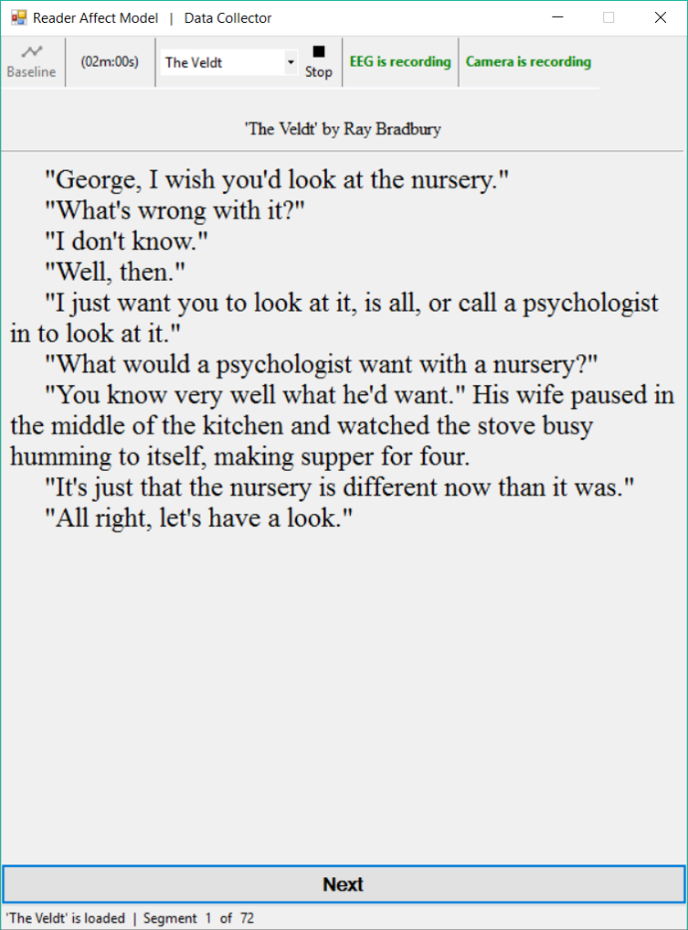

|  |  |
| --- | --- |
| C:\Users\ERDT\AppData\Local\Microsoft\Windows\INetCache\Content.Word\DataCollectorEmotion.png | **Hourglass of Emotions Model**   * **Pleasantness** is the person’s amusement by the stimulus. It ranges from grief to ecstasy. * **Attention** it person’s is interested in the stimulus, i.e. attention to detail. It ranges from amazement (negative surprise) to vigilance (positive surprise). * **Sensitivity** is the person’s comfortability with the stimulus, i.e. #triggered. It ranges from terror to rage. * **Aptitude** is the person’s is confidence (trust) in the stimulus. It ranges from loathing to admiration.   **Reader-Response Emotion Model**   * **Evaluative feelings** toward the text, such as the overall enjoyment, pleasure, or satisfaction of reading a short story. * **Narrative feelings** toward specific aspects of the fictional event sequence, such as empathy with a character or resonance with the mood of a setting. * **Aesthetic feelings** in response to the formal (generic, narrative, or stylistic) components of a text, such as being struck by a metaphor. |